Greetings from Jona Convex & Jona Travelindo Jakarta.

We are one of the fast growing PCO and travel agent company in Jakarta, Indonesia with vast experience and wide network that consist of extensive experienced and high achiever professionals with an objective to provide new direction in carrying out services in meetings, conferences, incentive events and exhibitions aside from our tour and travel services.

This coming September 2012, we are going to hold a travel mart which will exclusively promote Turkish tourism industry. We are inviting travel agencies, tour operators, tourist attractions, transportation and other representations of tourism industry in Turkey to exhibit or update their products directly to buyers in Jakarta. The Turkish Travel Mart 2012 is a two day travel trade industry event in a form of Business to Business networking session.

Together with this letter, we enclose herewith the outlines of the proposal and details information for your kind perusal. Should you have further inquiries regarding the above mentioned event, please do not hesitate to contact us.

Thank you and best regards.

JONA CONVEX & JONA TRAVELINDO

Event details

Name : Turkish Travel Mart 2012
Theme : Brings The Magical of Turkey
Organizers : PT. Jona Hartadi Travelindo
Proposed Date : Jakarta, September 17th – 20th
Venue : Hotel Gran Melia Jakarta

Program

Day | Activity | Remarks
Sunday  September 16th | Depart to Indonesia.
Monday  September 17th | Arrive in Jakarta.
Tuesday  September 18th | Registration.  Opening of the travel mart.  B2B – 1st session  Coffee Break.  Lunch.  B2B – 2nd Session  Coffee Break.
Wednesday  September 19th | Registration.  B2B – 1st session  Coffee Break.  Lunch.  B2B – 2nd Session  Coffee Break.  Farewell Cocktail.
Thursday  September 20th | Check out from the hotel and City Tour.  Transfer to Soekarno-Hatta International Airport.  Depart to Turkey.

Note : Time schedule to be advised later.

Registration Fee
US$ 2,690.-/booth occupied by 2 (two) delegates in a 3 x 3 m (9 sqm) decorated space.
A down payment of US$ 1,350.-/booth is subject for settlement when submitting the registration form. The allocation of booth(s) are based upon first comes first served basis.

Each booth consists of wall partition, fascia name, one round glass table and four dealing chairs, standard light, dust bin, MCB 2 ampere electric power point, power socket, rack/shelf for brochures and carpet needle punch flooring.

The price above includes :
- Lunch for 2 delegates/booth/day;
- 2 times Coffee Break/day (morning and afternoon);
- Farewell Cocktail party on September 19th

Promotional and Publicity
A proper preparation to promote and publish this event will be established to the right media. Promotion activities include press release, email distribution, banners, faxing service and promotion via website. An advertisement publishing the event will also be placed in one of the reputable local newspaper twice (seven days and one day prior to the event date).
Design Booth

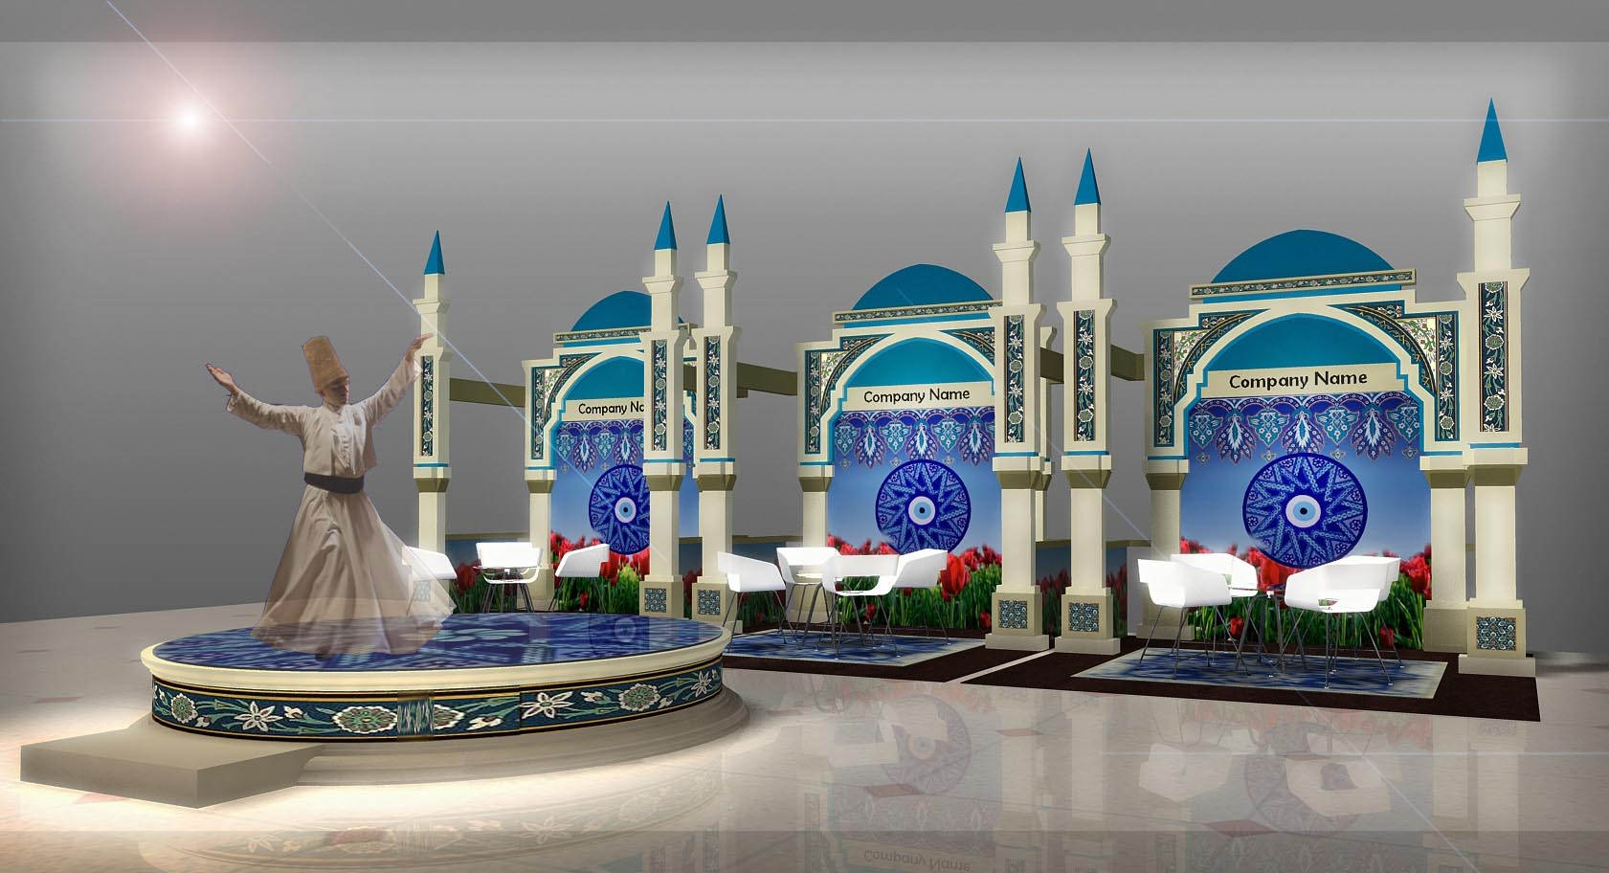

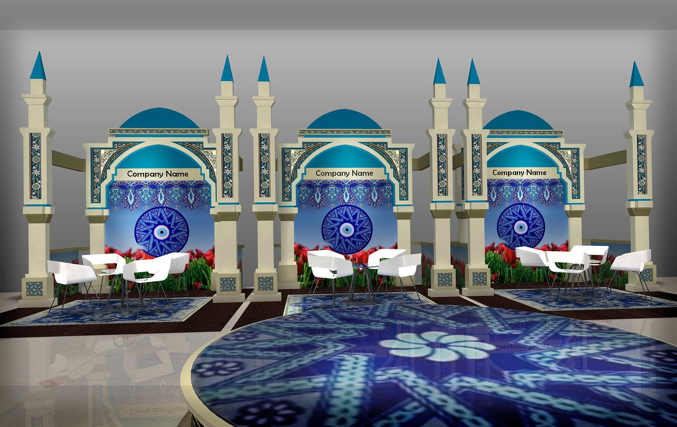

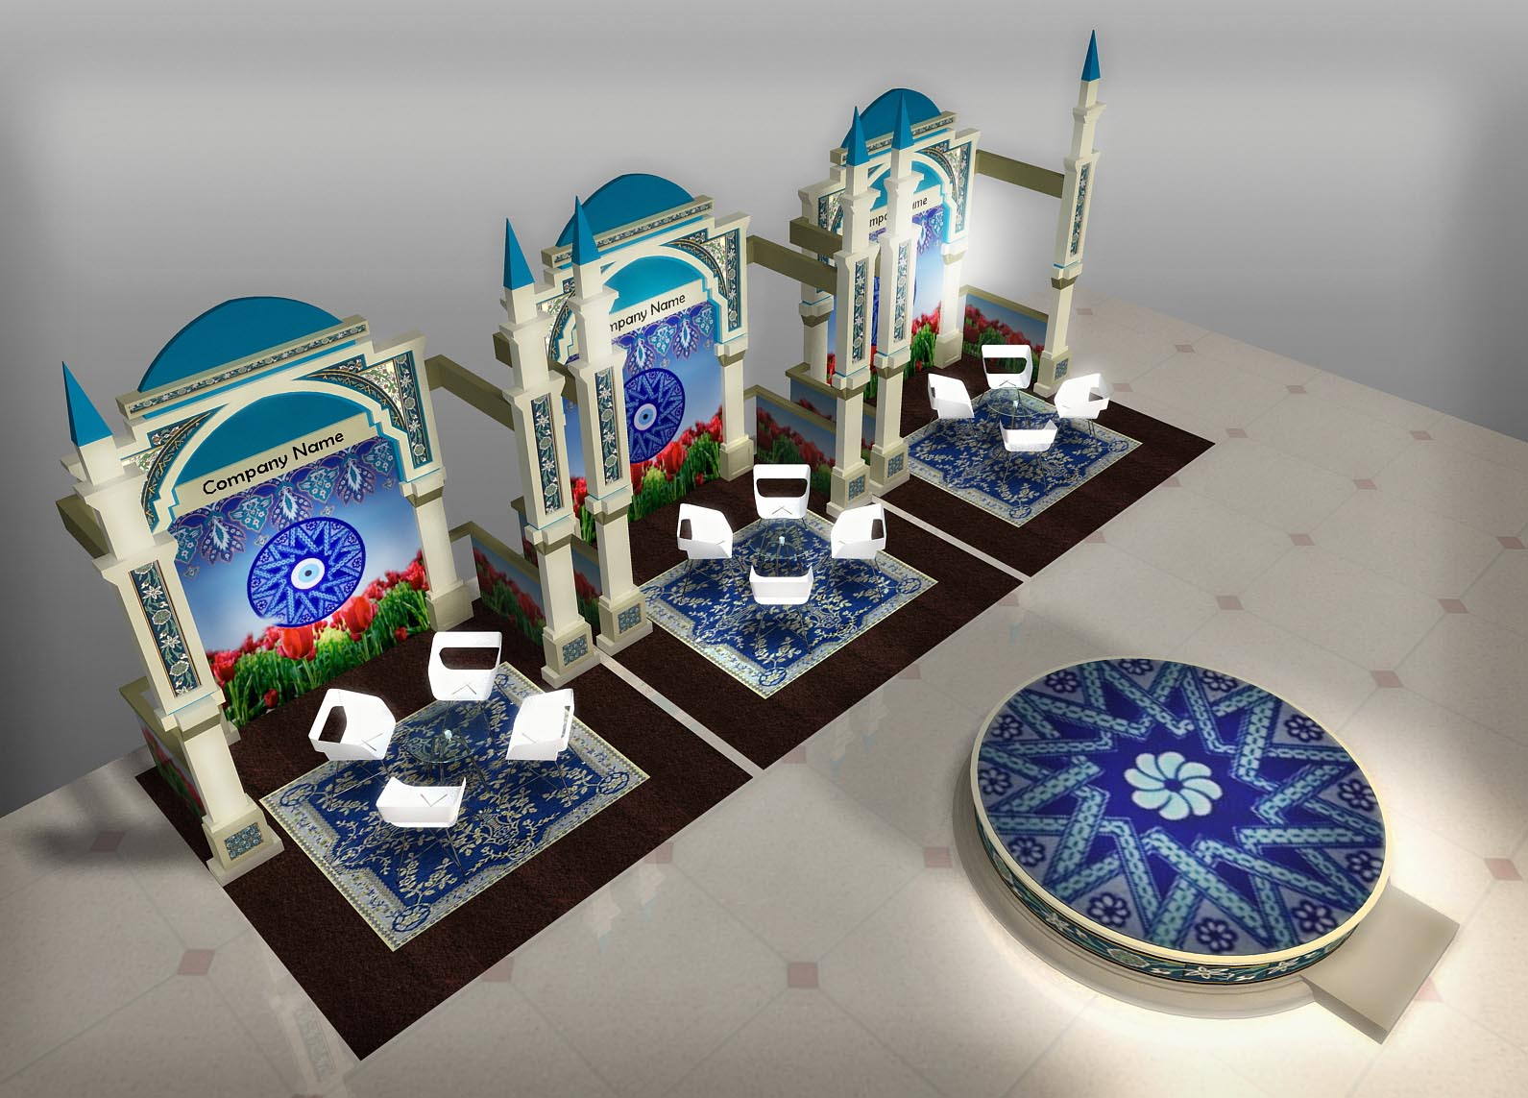

Venue

Hotel Gran Melia Jakarta
Jalan H.R. Rasuna Said Kav X-0. Kuningan, 12950, Jakarta, Indonesia

Deluxe Room : IDR 1.400.000,- nett (includes 21% tax & services and breakfast for single/double occupancy)

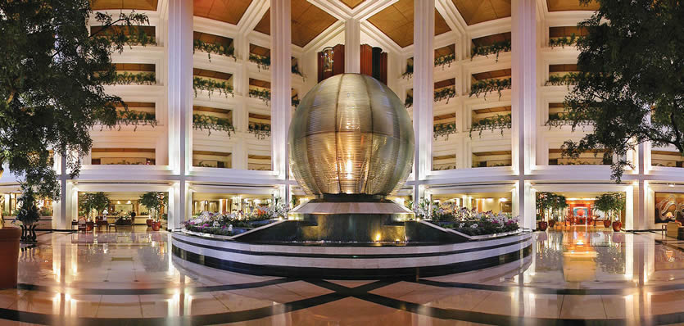
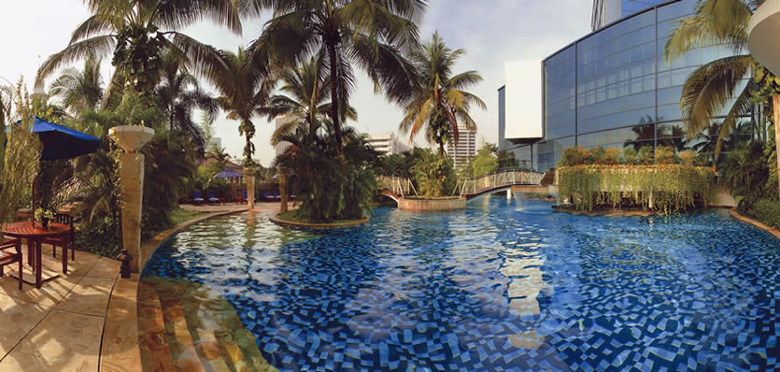

After Event
A feedback report will be produced to all participants to enable them getting the response of the event’s activities and also to improve the next event in order to gain an even bigger success.

Terms & Condition
- At any time, the organizer has the right to re-designate booths / space.
- All delegates must wear the official name tag provided by the organizing committee during the event.
- The hotel’s security guards will only patrol generally and does not include specific attention to individual booths. Exhibitors are responsible for all belongings on display and/or in transit to and from the exhibition venue. We remind Exhibitors not to let their booths be left unattended until all portable items have been secured.
- Exhibitors are to arrange their own insurance to cover all stages of their participation.
- Participants must conduct their business professionally and must not undertake promotional & marketing activities which are disruptive to the event.
- Any organization which fails to exhibit for whatever reason shall be liable for the full amount stated in the contract plus any additional costs that may be incurred by the Organizer. These terms cannot be varied under any circumstances.
- The Organizer reserves the right to cancel the Turkish Travel Mart 2012 if, in the opinion of the Organizer, the total number of booths sold does not justify the staging of the event.
- The Organizer reserves the right to cancel or shorten the Turkish Travel Mart 2012 in the event of any unforeseen circumstances, which are beyond the control of the Organizer.
If the event is cancelled before hand, then all payments made to the organizer shall be refunded. No other claims or compensation will be entertained and the Organizer will not be held liable for any loss incurred by the participant/exhibitor.
- If the event is shortened, there will be no refund of payments made. No other claims or compensation will be entertained.
- In terms of the needs of multimedia and other equipments/decoration must be rented from the local vendor/contractor by informing the organizer at minimum 2 (two) weeks prior to the event date. Exhibitors may directly dealt with the venue for telephone and internet line needs.
- Official Turkish Travel Mart 2012 photo & videographers will be taking photo & videos during the 2 days of Turkish Travel Mart 2012. The organizer shall be entitled to use such photographs, for the purpose of marketing the Turkish Travel Mart 2012 in the future.

Sponsorship

Gold – for investment of US$ 1,500.-
- The sponsor’s logo will be printed on our 3 (three) printing materials, which are : banner at Press Conference, guidance book, and goody bag.
- The sponsor will be mentioned at the Cocktail Party.

Silver – for investment of US$ 1,000.-
- The sponsor’s logo will be printed on our 2 (two) printing materials, which are : guidance book and goody bag.
- The sponsor will be mentioned at the Cocktail Party.

Pre & Post Tour

YOGYAKARTA ART AND HERITAGE
3 DAYS/2 NIGHTS

About Yogyakarta, Indonesia
Yogyakarta, one of the three Special Districts of Indonesia, is considered the foremost center of Javanese Culture. Located at the foot of the active volcano Mt. Merapi, the fertile plain of Yogyakarta was established in the 16th and 17thcenturies. The Seat of the Mighty Javanese Empire of Mataram, Yogyakarta has a special, gentle charm which seldom fails to captivate visitors. Yogyakarta is also called JOGJA.

Day 01:
Arrival Adisucipto Yogyakarta Airport – Prambanan Hindu temple (L)
- Arrival at Adi Sucipto Yogyakarta airport – greets and meets – check in hotel or direct visiting the magnificent Prambanan Hindu temple. This temple is believed to have been built by King Belitung Maha Sambu during the middle of the ninth century. Its parapets are adorned with a bas relief’s depicting the famous Ramayana Ballet.
- Check in hotel and rest at hotel
- Nite at hotel

Day 02:
Borobudur Buddhist temple + Yogyakarta City Tour (B)
1 hour from Yogyakarta, drive to Borobudur, a Buddhist temple and located 42 km west of Yogyakarta. It is one of the world’s most famous temples, standing majestic and serene on a hillock overlooking lush green fields and distant hills. The shrine is the worlds and most complete collection of Buddhist relief.
- Proceed to Yogyakarta Sultan Palace, built in grand and elegant Javanese Architectural style, lies in the center of municipality. It was built in 1756 by Sri Sultan Hamengku Buwono 1.
- Continue to Taman sari Water Castle
- Visit Kotagede, a neat, little and old town of Yogyakarta which was once the seat of The Mighty Mataram Kingdom. This town has become famed for being the center of Silver work industry. Guests will have a chance for Silver work exploration inclusive shopping at the silver gallery, if interested to buy.

Day 03: (B)
Departure time

US$ 432/pax : minimum 1 pax (nett) includes dinner
US$ 294/pax : minimum 2 pax (nett) includes dinner
Accommodation at Hotel Melia Purosani Jogjakarta (*5)
The price above excludes air ticket Jakarta-Jogjakarta-Jakarta v.v. IDR 1.942.000,-/pax

BALI – FREE & EASY
3 DAYS/2 NIGHTS

Bali is an island located in the westernmost end of the Lesser Sunda Islands, lying between Java to the west and Lombok to the east Indonesia. It is one of the country's 33 provinces with the provincial capital at Denpasar towards the south of the island. Bali received the Best Island award from Travel and Leisure in 2010. The award was presented in the show "World's Best Awards 2010" in New York, on 21 July. It is also the largest tourist destination in the country and is renowned for its highly developed arts, including traditional and modern dance, sculpture, painting, leather, metalworking, and music. Bali, a tourist haven for decades, has seen a further surge in tourist numbers in recent years.

Day 01:
Arrival Ngurah Rai Airport – Half Day Tour (D)
Half Day Tour’s options are :
1. Garuda Wisnu Kencana - Uluwatu Tour :
- Visit the Cultural Park of Garuda Wisnu Kencana (GWK), a private cultural park on the Bukit Peninsula at the southern end of the island of Bali. It is devoted to the Hindu god Vishnu, and his mount, Garuda, the mythical bird who is his companion. Currently, the statue of Vishnu is 23 metres (75.5 ft) high, although the original plan was for a 146-metre (479 ft) gold-plated Vishnu riding Garuda on top of an 11-storey entertainment complex. When it's completed, it will be the largest statue in the world.
- Visit Uluwatu, Pura Luhur Uluwatu is a Balinese sea temple. Built in the 11th century, it is one of nine directional temples meant to protect Bali from evil spirits. It is located in Pecatu village, Kuta South District of Badung Regency of Bali.
- Dinner at the local restaurant, and transfer to the hotel.

2. Tanah Lot Tour :
- Shopping at Joger Krisna, a shop where you can buy unique t-shirts and accessories. Joger shop is a very well known shop in Bali, many tourists buy their products for souvenirs for all ages.
- Continue by visiting Tanah Lot, a rock formation off the Indonesian island of Bali. It is home of a pilgrimage temple, the Pura Tanah Lot (literally "Tanah Lot temple"), and a popular tourist and cultural icon for photography and general exoticism.
- Dinner at the local restaurant, and transfer to the hotel.

Day 02:
Full Day Tour (L, D)
The tour begins after having breakfast at the hotel. Starts at around 08.00 or 08.30 am and ends at around 18.00 or 19.30

Options for the full day tour are :
1.Kintamani Tour :
- Visit Celuk which is well known for gold and silver smiths. Lunch at the local restaurant in Kintamani area. Continue by visiting traditional village “Penglipuran” and last the traditional market Pasar Sukawati. Huge number variants of souvenir are available at this market, with a very competitive price. Last but not least, watch traditional dance performance such as Barong and Keris.
- Dinner at the local restaurant, and transfer to the hotel.

2.Bedugul Tour :
- Visit the 18th-century Royal Temple of Pura Taman Ayun, the largest and most impressive architectural edifice of its type on the island.
- Danau Beratan (Lake Beratan) contains three caldera lakes at the north of Bali island. The volcanic complex covers 11 × 6 km wide area. The largest post-caldera cone within the complex is Gunung Batukaru.
- Pura Ulundanu (Ulundanu Temple), also known as "Pura Ulun Danu," "Pura Batur" or "Pura Bat" is the second most important temple in Bali, after Pura Besakih. Built in 1926, the temple is dedicated to Dewi Danu, goddess of lakes and rivers. "Ulun Danu" literally translates as "head of the lake".
- Lunch at the local restaurant in Bedugul area.
- Alas kedaton, a small forest with the width about 6-7ha located in the middle of the rice field in Tabanan regency, west part of Bali. The monkeys who dwell in this forest, they jump up and down in temple wall, take a bath in moat or there is also hang out in few leaves representing impression view.
- Dinner at the local restaurant, and transfer to the hotel.

Day 03:
Check out hotel, transfer out.

US$ 467/pax : minimum 1 pax (nett) includes dinner
US$ 342/pax : minimum 2 pax (nett) includes dinner
Accommodation at Discovery Kartika Plaza Hotel Bali (*5) – Kuta Beach Area
The price above excludes air ticket Jakarta-Denpasar-Jakarta v.v. IDR 2.978.000,-/pax

NOTE :

There are still lots and lots of tourist attractions or destination in Jogjakarta and Bali. We will be more than pleased to customize our tour packages in accordance to your wish.

