The Organisers: Who is Who

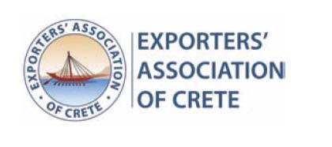
The Exporters’ Association of Crete (EAC) was established in 1994 and is promoting the extroversion of Cretan companies. Through International Fairs, Business delegations, matchmaking programmes and other actions, EAC, one of the most dynamic regional Associations in Greece with recognized contribution in the export trade, is propelling Cretan Diet and the products of the island of Crete to the International Market.
www.crete-exporters.com

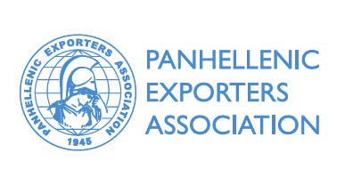
The Panhellenic Exporters’ Association (PEA) was established in 1945 and represents the entire body of Greek Exporters. Members of PΕΑ are companies, cooperatives and organisations engaged in the production, manufacturing and trading of a large variety of products that are exported internationally. PΕΑ's scope is to assist all interested parties abroad in familiarising with Greek export production.
www.pse.gr

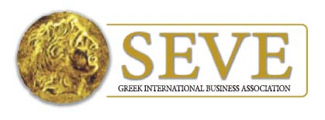
The Greek International Business Association (SEVE) is the most dynamic association in Greece, representing the Greek business export community. SEVE has more than 3,000 direct and indirect members, supporting their extroversion efforts on a daily basis. SEVE has significant experience in international business matchmaking and is acting as the Official National Counsellor for all “Partenariat” events in Greece.
www.seve.gr

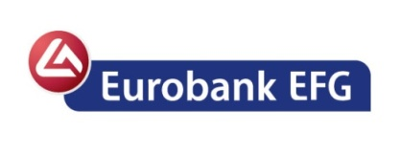
Eurobank EFG Group is a European banking organization with total assets of € 81.6bn, (as at 3Q 2011), offering universal banking across Southeastern Europe, London and Luxembourg. Greece’s second largest bank, Eurobank EFG, also enjoys leading positions in Bulgaria, Romania and Serbia. Eurobank EFG is part of the EFG Group, an international banking group, whose operating holding company is European Financial Group EFG (Luxembourg) SA. At Eurobank EFG we remain committed to the effort of supporting our clients to weather τhe economic crisis and actively contribute to the development of the economies of the countries in which we operate.
www.eurobank.gr

