
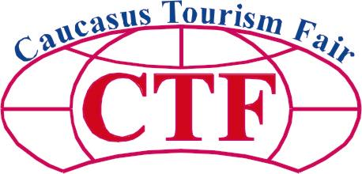

14th International Tourism Fair in Tbilisi, Georgia
6-8 April, 2012
Ladies and Gentlemen,
We take a pleasure to invite you to the 14th International Tourism Fair organized by Exhibition Center ExpoGeorgia in 6-8 April, 2012, at the fairground of ExpoGeorgia Co, in Tbilisi, Georgia.

The Event is organized by Exhibition Center ExpoGeorgia with support of the State Department of Tourism and Resorts of Georgia, Agency of Protected Areas of Georgia and Tbilisi City Hall.

Advantageous geopolitical situation of Georgia gives an opportunity to bring together all regional products and create best environment for development of regional tourism.
The concentration on rebuilding Georgian holiday destinations and the increasing of interest of Georgians to explore new attractions of the world encourages the development of Domestic, Regional & Outgoing Tourism and Hotel Industry in the South Caucasus Region. This will be the leading themes of the Tourism Exhibition 2012 in Tbilisi.

Why to exhibit in Georgia

- The only Caucasus country on Black Sea, connecting the Europe and Asia. Georgia offers the ideal destinations for adventurous traveler with a keen eye for cultural sights.
- About 650 million dollars were invested in Georgian tourism industry in previous two years, the number of Incoming and outgoing tourists in Georgia increased as well.
- CTF 2012 is dedicated to the promotion of foreign tourism destinations and the Georgian reviving domestic tourism.
- A high-powered expert visitors’ promotion campaign will be implemented to attract the right group of potential business partners and general public.
- This is the best place to promote your company and the country on the new Caucasus Market of business opportunities with a total population of 20 mln. People.

Previous Exhibition Data

 Number of exhibitors: 180  Number of participated countries: 5
 Number of professional visitors: 2790  Exhibition area: 570 sq.m

For more information about the fair, please visit http://www.expogeorgia.ge
We look forward to welcoming you either as an exhibitor or visitor at our fair and witness the success of your company on the new market of business opportunities.
Faithfully yours,

Nino Gamrekeli
Project Manager

PRODUCT DIRECTORY

TRAVEL ORGANIZATIONS:
- International Travel Organization,
- National Tourism Organization,
- Congress/Conference Organizer,
- Tour Agent,
- Tour Operator;

ACCOMMODATION:
- Hotel, Resort,
- Camping-site,
- Equipment for Accommodation

INFORMATION AND ADVICE:
- Analysis,
- Hardware and Software,
- Consulting, Education,
- Financial,
- Information System,
- Investment Program,
- Multi Media,
- PR Agencies,
- Publisher/Travel,
- Magazine,
- Reservation System,
- Science and Research,
- Travel Insurance,
- Travel Medicine;

TRANSPORT COMPANIES:
- Airline Company,
- Airport,
- Bus Companies,
- Car Rental,
- Railway Company,
- Shipping/Ferry Line;

CULTURE & ENTERTAINMENT:
- Art salons,
- Restaurants,
- Leisure Park,
- Music and Art Festival,
- Theater/Opera house,

