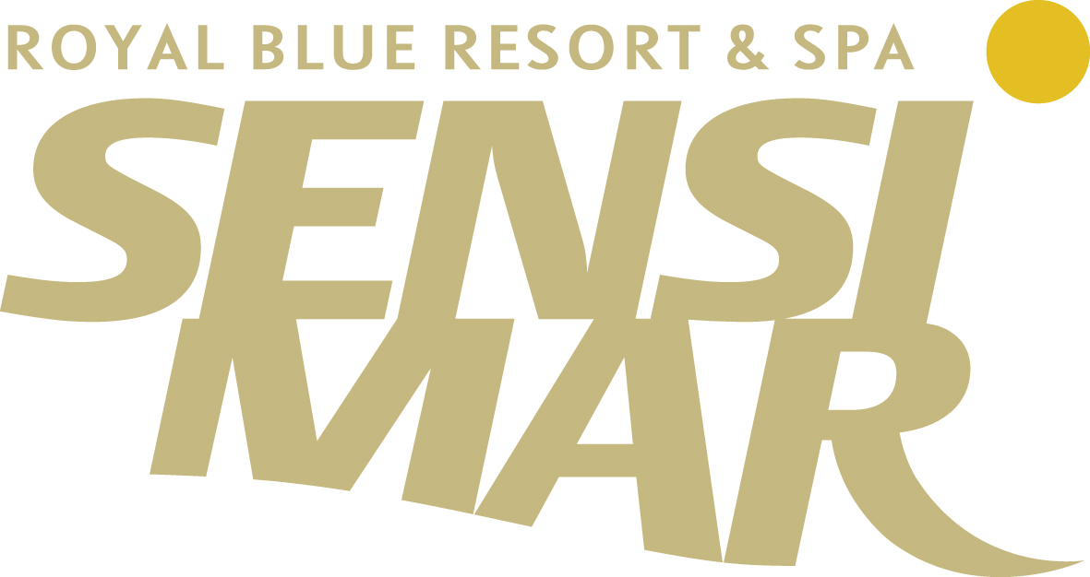

Sensimar Royal Blue Resort & Spa

No holiday is complete without the sea…and the image of water as the elixir of life.
The sound of the sea…
The scent of the sea breeze…
Seafood delicacies and more…
Sun, salt and spa products for the skin…
Sensimar Royal Blue Resort & Spa – My home by the Sea!

The Hotel

The 5* Sensimar Royal Blue Resort & Spa, is a tranquil exclusive resort on the northern coast of the island of Crete that allows you to lose yourself in authentic luxury & quiet sophistication. With its own private bay and an endless horizon of Cretan Blue, where the sea meets the sky in a harmonious kaleidoscope, you will find your getaway to an unparallel sensorial journey.

The complex consists of numerous public and private swimming pools as well as colorful gardens which extend throughout the resort fulfilling the senses with a unique blend of well-being and relaxation. Natural stone has been used extensively with dedicated passion for detail, in the decoration of all outdoor areas, thus creating the perfect mix between sophistication and natural elegance.

Guests will be pampered beyond conventional luxury with singular service standards and the renowned Cretan hospitality. The understated elegance of the 190 rooms, suites and villas, which have been built in a Mediterranean Village style, the uncompromising unique flavors of the resort’s cuisine, the unique settings for the organization of your events and the mystical magic of the Pure Senses Spa are just the introduction to an experience that extend beyond the realms of a luxury resort.

How to Reach

Location
Crete: the land of Daidalos and Ikaros, the birthplace of Zeus, the cradle of the Minoan civilization, the home of El Greco, Vitsentzos Kornaros and Nikos Kazantzakis.
Crete: the southernmost part of Europe, a rich and beautiful island washed by the Aegean waves from side to side, with stunning & diversified landscape with steep slopes, sandy beaches, olive groves and vineyards, mountains, gorges & gleaming plateaus scented with wild fennel, diktamo and fresh basil.
Crete: the land of full bodied wine & pungent raki, the land of endless feasts and warlike dances, the island that never sleeps!
Crete: a land with its own tradition and its own character, with black baggy breeches and fringed kerchiefs, with Cretan people relatively unscathed, retaining their culture but above all their innate sense of traditional hospitality.
In a few words, although statistically small, Crete is huge in its diversity!

The 5* Sensimar Royal Blue Resort & Spa lies on the northern coast of the island next to the small traditional village of Panormo, only 22 km away from the picturesque & city, historical town of Rethymnon and 55km from the island capital Heraklion.

How to Get:

To Crete
By air: There are daily scheduled flights from “El. Venizelos” Athens International Airport to “Nikos Kazantzakis” Heraklion International Airport (55klm) and “Ioannis Daskalogiannis” Chania International Airport (86klm). Charter flights from most European destinations arrive from April to November to both airports of the island.
By Sea: Daily itineraries link the port of Rethymnon and Heraklion with the port of Piraeus (Athens)., Ios etc). There are also daily or weekly connections with islands of the Aegean Sea (Santorini, Milos

To the hotel [from ports and airports]
By Taxi & Luxury Car Service
Available on request from the hotel or at the ports and airports.
Through Bus Services
Regular public bus services run from a bus stop just 300m from the resort to Heraklion, Rethymnon & Chania and vise versa.
By Car
Rent a car services upon request at the hotel.

Accomodation

Your home at the sea… This is exactly what all our guestrooms, suites & villas are designed to be! Α haven of relaxation and recreation, the ultimate paradise to relax, unwind and indulge yourself in luxury. The fusion of traditional and contemporary design with all comforts of a luxury resort, create an atmosphere like home, a place you would never want to leave.
Retreat to one of the 190 modern rooms, suites and villas, acquire the sense of luxury and simplicity at the same time and experience the most picturesque accommodation experience with a view of the endless horizon of the sea and sky!!

SUPERIOR GUESTROOMS – Sea View
Our stylishly decorated in warm and soothing tones superior guestrooms (approx. 30 sq.m.) offer luxurious settings and elegant amenities to ensure an experience of absolute comfort. Gloriously situated overlooking the sea, all rooms dispose king or twin size beds and simple designer interiors, that will offer you the utmost relaxation and serenity that is dominant throughout the resort. Do not miss to indulge yourself in the luxury, that only a five star hotel can offer.

SUPERIOR GUESTROOMS – Side Sea View
Our stylishly decorated in warm and soothing tones superior guestrooms (approx. 30 sq.m.) offer luxurious settings and elegant amenities to ensure an experience of absolute comfort. Gloriously situated overlooking the sea from the side of the balcony, all rooms dispose king or twin size beds and simple designer interiors, that will offer you the utmost relaxation and serenity that is dominant throughout the resort. Do not miss to indulge yourself in the luxury, that only a five star hotel can offer.

SUPERIOR GUESTROOMS – Garden View
Our stylishly decorated superior guestrooms (approx. 30 sq.m.) offer luxurious settings and elegant amenities to ensure an experience of absolute comfort. Room colors, straight from nature’s table – brown, beige and cream –complemented by the colorful views of the resort’s rose gardens that give away the most enchanting scent will help you lose yourself in the utmost relaxation and serenity that is dominant throughout the resort. Available with twin or king size beds and spacious bathroom with bathtub.

SUPERIOR GUESTROOMS with sharing pool
Our elegantly designed superior guestrooms of 35 sq.m, with twin or king size beds, offer luxurious comforts and elegant amenities that create the sensation of utmost serenity and relaxation. Their private balcony offers impressive sea views or refreshing rose garden views and is open to a spacious terrace with a sharing pool furnished with sunbeds and umbrellas for all neighbouring rooms, where guests can enjoy the sun, at a more private and secluded space. Enjoy your dive in the pool, relax and unwind! And of course don’t miss to take pleasure with a glass of wine, for the absolute sense of relaxation and fulfillment!

LUXURY GUESTROOMS waterfront with Pool
Our comfortable and elegantly appointed Luxury Guest Rooms with a size of 35sq.m, are located at the waterfront of the hotel looking out to a breathtaking panoramic view of the Aegean Blue! With the luxury of an individual pool, terrace and garden you will lose yourself into the magnificent views of the Aegean Sea. Relax on the beautiful terrace and enjoy the peacefulness of the blue horizon of the sea and sky that will enchant your stay! Take the time to enjoy the sun together with a dive in your pool or make your terrace the ideal setting for the most unique and private al fresco dining experience! And of course spend some quality time in your room! Furnished in a minimal style with king size bed and sofa bed together with the marble bath with elegant amenities and hydro- massage, the room will be your absolute haven, a place that feels just like home!

SUPERIOR SUITES waterfront
These waterfront sun-filled superior suites with a size of 55sq.m each are located on the 1st floor of a two story building. Each one composes of a spacious living room with private balcony with outdoor Jacuzzi and a bedroom with king size bed and amazing sea views. With its modern décor, relaxing furniture and elegant amenities it is designed to offer guests the most upscale comforts of a luxury holiday resort. Lounge on your bamboo parlor on the balcony, enjoy a Jacuzzi ‘session’ overlooking the endless horizon of the sea and sky or just snuggle up indoors. Unwind, forget time and relax. Leave all details to us and let us make your stay an unparallel sensorial journey!

LUXURY SUITES waterfront with Pool
The modern design of the Luxury Suites interior reflects a distinctive architecture with clean lines and simple tranquility which complements the exterior space and nature. Luxury Suites with a size of 55sq.m are located directly at the waterfront, on the ground floor of a two story building and offer the luxury of a spacious living room, bedroom with king size bed, marble-lined bathroom with hydromassage, as well as a separate shower cabin. Further accentuating your luxury all suites are complemented with an individual pool with sun beds, terrace with lounge chairs and lawn area. Soak up the sun from your own private pool or enjoy a romantic candle light dinner under the stars, just a few meters from the sea! Or just pull back the curtains, lay back on your comfortable couch or bed, let the sunlight fill your room and lose yourself into the endless horizon of blue, where the sea meets the sky in a harmonious kaleidoscope.
LUXURY VILLAS waterfront with Pool
Refreshing and serene colors, contemporary décor highlights, sun filled rooms that feature gorgeous sea views: Luxury Villas, on maisonette style with a size of 58sq.m, are located at the waterfront, offer a deluxe home away from home and are especially designed for guests seeking luxury and exclusivity. Each villa consists of an elegantly appointed living room with TV and a bathroom at the ground floor, as well as a spacious bedroom with a king size bed and bathroom with air- or hydro- massage at the first floor. To further enhance the sense of luxury, the villas are open to a terrace with a private pool with sun beds, as well as a lawn area with flowers.
Savor romantic dinners under the starry sky, dip into your private pool or just lounge in your bamboo furniture with a cocktail in hand, mesmerized by the stunning views of the breathtaking sunset, with the sun diving into the sea right before your eyes! If you wish to stay indoors, plump up the pillows, pull back the shadings and let the sunlight fill the room, as you lay bewitched by the beauty of the sea and sky! Our luxury villas are the ideal place to unwind and relax in privacy and style, a place where nothing has been left to chance, a place that feels just like home!

ROYAL SUITE
The Royal Suite more than lives up to its name, as it is a suite of upgraded aesthetics, décor highlights, sun-filled rooms and stunning views, designed with respect and harmony to the surrounding nature.
At approximately 450 sq. m. the Royal Suite is the epitome of sophistication, a 3-story building of unrivaled splendor, featuring a spacious living room with welcoming lounges, an office for private meetings, a master bedroom with open bathroom and jacuzzi, two spacious bedrooms with sea view, a separate floor with Gym, Sauna and indoor swimming pool, a fully equipped kitchen for private chef with separate entrance for the staff and battler service (upon request), extensive gardens with flowers, a private entrance, two parking spaces, two swimming pools and a kid’s pool, a jacuzzi on the balcony, a BBQ with all relevant amenities and services, a terrace with bamboo furniture, sun beds and umbrellas.
Nothing is left out and everything has been appointed and designed with special care to detail. Luxury meets romance and elegance in this super premium residence exuding refinement. Our Royal Suite is meant to be your haven for lavish living with breathtaking views of the sea and sky, where you can forget time, relax and enjoy the most unforgettable experience of your life!
Ask for the full menu of services for the Royal Suite

IN ROOM AMENITIES
✓ Air condition ✓ LCD Flat Screen ✓ Satellite TV ✓ Direct Dial Phone ✓ Internet Connection ✓ Laptop Size Electronic Safe ✓ Fully Equipped Mini bar or mini Refrigerator ✓ Spacious Bathrooms with two washbasins & music ✓ Hairdryer ✓ Shaver Outlet ✓Telephone in bathroom ✓ Bathrobes ✓ Slippers ✓ Elegant Amenities ✓ Laundry Service ✓ Tea & Coffee Station ✓ Weight Scales ✓ Lighted magnifying mirror in bathroom .
Dining & Bars

Restaurants
Delve into new tastes and enlightened experiences at Sensimar Royal Blue Resort & Spa with a view of the big blue of the sea and sky. With a rich offering of cuisines from around the world and a wide choice of settings, there is a dining option sure to please even the most discriminating palate.
Epicurean delights with dishes grilled to perfection at the Symposium main restaurant and magnificent three a la carte restaurants, Junsui Asia, Il Posto Azzuro and Kulinarium will impress the most discerning of guests.

The delightful dining options at Sensimar Royal Blue Resort & Spa include:

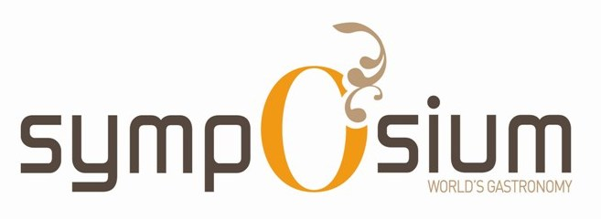
Symposium is an electric mix of live cooking station, a true assault on all your senses, making your dining experience an exciting journey from entrée through to dessert. Savour the fresh approach to food and cooking styles from China and Japan or indulge in authentic Greek, Italian, Spanish and European flavors. Alternatively, experiment with Indian sensations or sample the purity of seafood or meat; the choice is varied and diverse.

Guest may dine inside in a smoke-free environment or enjoy the outdoor terrace with breathtaking sea views.

Cuisine: International Buffet
Dress Code: Casual Smart
Entertainment: Background music and occasionally live music
Capacity: Restaurant - 440 persons


Italy on a plate!
Italian recipes are mostly about antipasti, pizza, pasta & risottos. Enjoy authentic Italian dishes and unique flavors with a gourmet touch at the Italian Spot of Sensimar Royal Blue Resort & Spa.
Il Posto Azzuro is an incompatible restaurant of impeccable character where you will experience a refined good taste. Ideal for lunch next to the pool with a breathtaking view, exudes warmth and elegance.

Cuisine: Italian
Dress Code: Casual
Entertainment: Background music
Capacity: Restaurant – 80 persons

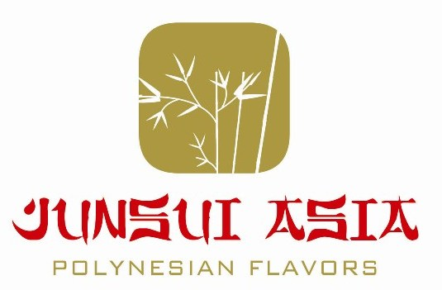
Pure tastes from the East!
Polynesian flavors and décor reflects stunning blends of Asian Fusion complemented by a sophisticated yet tropically modern, relaxing and fun dining experience.
The Japanese word for ‘pure’, Junsui is a new, authentic Asian restaurant set within the opulent interiors of Sensimar Royal Blue Resort & Spa. With breathtaking view over the sea and an upper-stylish dinning surrounding, Junsui is the definitive Asian restaurant in a setting which is a pure delight. The Culinary team prepares a wide selection of Japanese, Chinese, Thai and Polynesian dishes that will surpass your expectations.
Guest may dine inside in a smoke-free environment or enjoy the outdoor terrace with the outstanding sea view.

Cuisine: Polynesian, Thai, Chinese & Japanese
Dress Code: Smart
Entertainment: Background music
Capacity: Restaurant – 80 persons

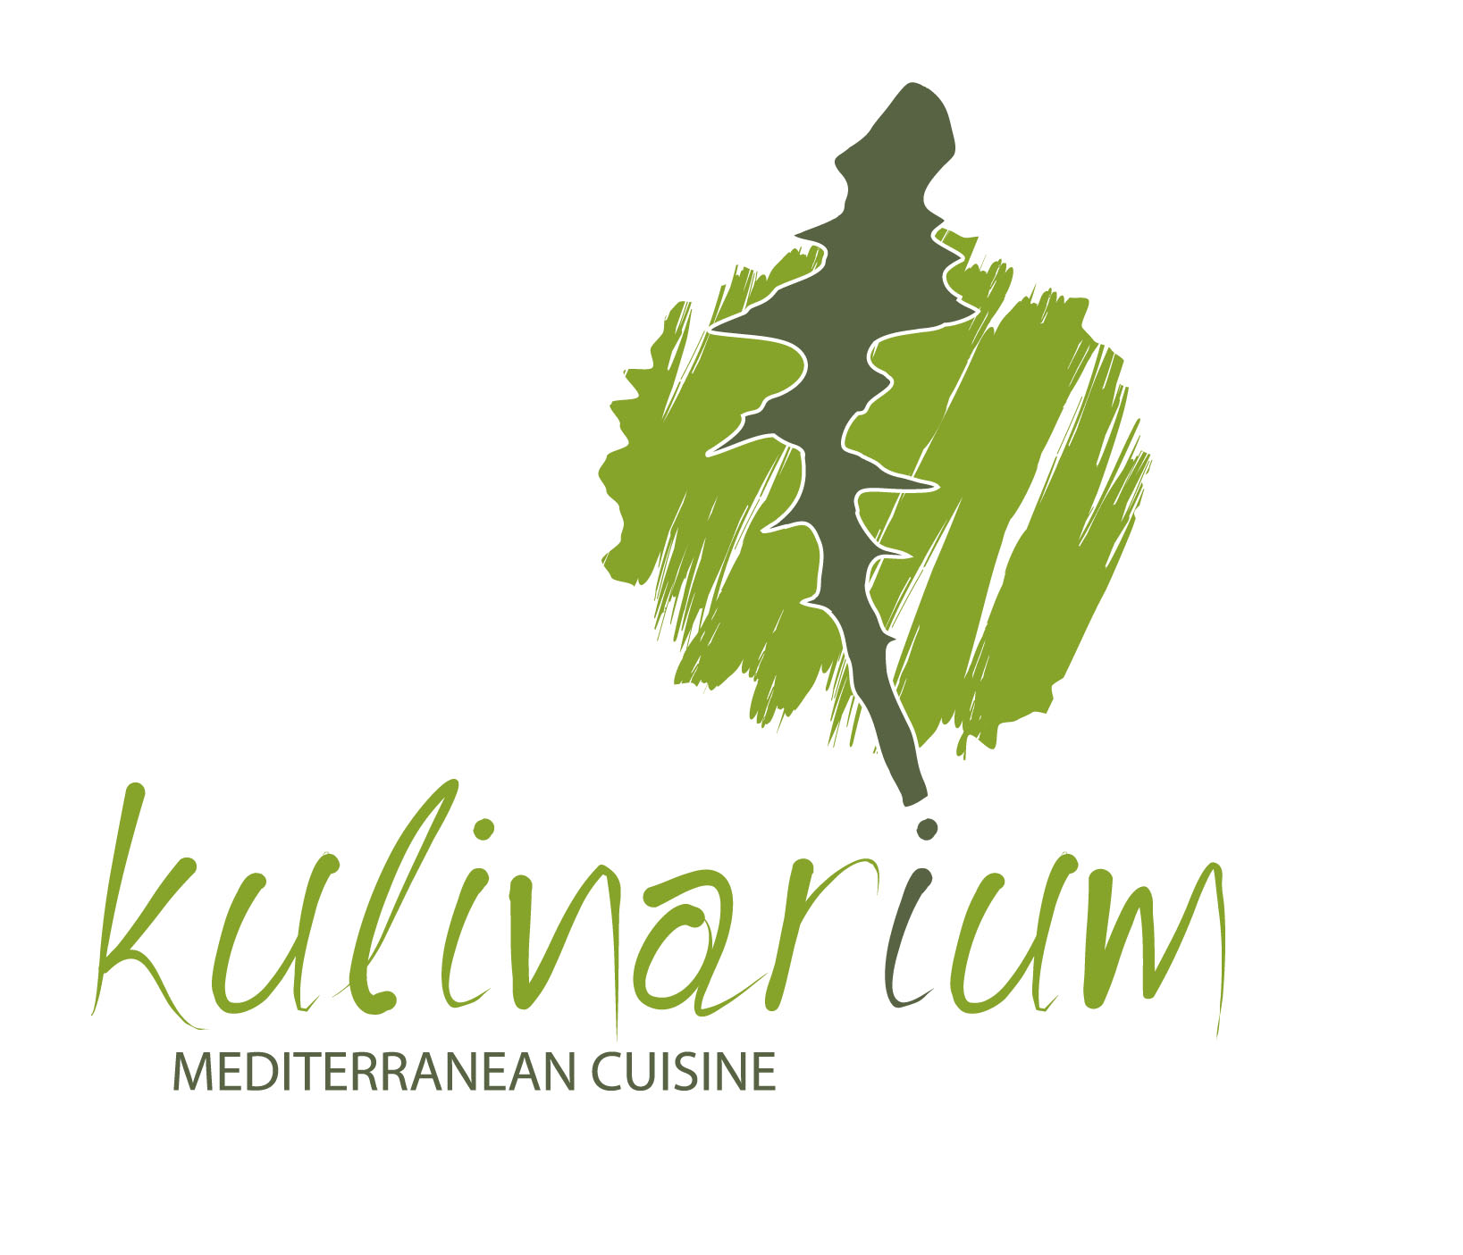 A fantastic voyage through the flavours and aromas of the countries facing on the magical Mediterranean Sea. Mediterranean cuisine, simple but so rich, containing all the flavours of the sea and nature, all the goodness of simple preparation and genuine ingredients. Inviting and fragrant, light hearted and colourful, based on generally simple dishes that require little cooking time, a style of cooking that prefers vegetable fats and for this reason nutritionists all over the world recommend.
Mediterranean flavors with a Cretan touch!
Kulinarium will create an unforgettable experience to its dinners at the edge of the resort facing the blue crystal waters of the main swimming pool and the endless blue of the Cretan Horizon…. A fantastic voyage through the flavours and aromas of the countries facing on the magical Mediterranean Sea. Mediterranean cuisine, simple but so rich, containing all the flavours of the sea and nature, all the goodness of simple preparation and genuine ingredients. Because, delicious food starts with fresh & high quality ingredients; in other words, the best of nature in your dish!
Cuisine: Mediterranean with a Cretan touch
Dress Code: Casual Smart
Entertainment: Background music
Capacity: Restaurant – 100 persons
Bars
Bars with a difference; pure elegance, relaxation n & class at the bars of Sensimar Royal Blue Resort & Spa.
The hotel’s seamark Blue Time Lounge Bar offers our 10 modern and 10 classic cocktails that will intrigue even the most demanding palettes. Stop by the Cigar Bar for unique single malt whiskeys & superb premium cigar selections. Stylish and warm, Kafeneio is the perfect place to indulge with friends, relish a Greek coffee made in Hovoli, taste traditional spoon - sweets and enjoy the sporting fun on the big screen. And last but not least, unwind with a drink, enveloped in the exotic ambience at the Pool or Beach Bar.


“Blue Time” is the hour that you can watch the sun setting in the sea and the sun rising from the sea. A truly unique view, accompanied with a cocktail, a special selection of the best 10 classic and 10 modern cocktails. You can either enjoy a spotless cappuccino by our specialists Baristas, or a refreshing Royal Blue Fruit Feast. And all that in a spacious modern and luminous area at the lobby with breathtaking views of the sea & sky.
Bar List: 10 Best Modern & 10 Best Classic Cocktails, Speciality Coffees and a lot more.
Dress Code: Casual Smart
Entertainment: Background music, occasionally live music & DJ Nights
Capacity: 200 persons

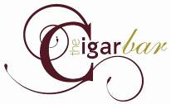

‘Cigars are a sign that one takes the time to enjoy something’

The ideal location for patrons to savour cigars that aficionados recognize to be amongst the finest produced. Complemented with an extensive single malt whiskey or a cognac, patrons can enjoy a game of chess or just the reading of a book from the library, available there. Elegant, stylish and classy ambience, a place to remember, a place that travels you to another era of aesthetics.
Bar List: Cigars, Single Malt Whiskies & Cognacs
Dress Code: Casual Smart
Entertainment: Background music
Capacity: 50 persons

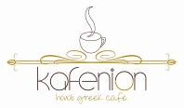

A unique Cretan ambience, surrounded by the Greek coffee aromas and homemade traditional desserts will indulge your summer evenings. You may also enjoy sports nights with an ouzo or raki and meze.
Bar List: Greek Coffee in Hovoli, Greek traditional delicacies
Dress Code: Casual Smart
Entertainment: Background music, Big screen for sports
Capacity: 50 persons



Located next to the 2 main hotel pools, offering all day cold drinks and homemade snacks. Ideal for a mojito or a watermelon salad on a hot summer day!
Bar List: Variety of snacks and Cold Drinks
Dress Code: Casual
Entertainment: Background music, Occasionally DJ music
Capacity: 200 persons



With a variety of more than 80 different labels from all over the world, in a classic ambience, perfect for wine tasting and selection, you will certainly find your match. Allow us to take you a wine trip in the roads of Greek wine. Can be booked for private dining upon request.
Wine List: Greek and International
Dress Code: Casual
Entertainment: Background music
Capacity: 10 persons
Meetings & Events

At Sensimar Royal Blue Resort & Spa, you have found the perfect venue: ultra-modern & chic full of elegance and splendour. Just name the occasion…be that party, anniversary, christening, wedding, birthday, business meeting or any other event: we have the venues, the facilities and the expertise! We provide everything, so that you have nothing to worry about! Just choose one of the indoor or outdoor settings of our hotel and celebrate the unique moments of your personal or professional life like nowhere else!

Receptions & Social Occasions
‘Sparkle under the stars as you celebrate your special day at Sensimar Royal Blue Resort & Spa!!!’
Weddings & Social Occasions at the Sensimar Royal Blue Resort & Spa are the staff of memories. Whether for an intimate gathering or a large reception, our staff’s commitment to superior service will make your celebration uniquely your own! Enjoy a chic cocktail soiree or intimate gathering & cast a spell on your guests. Overlooking the stunning infinity edge sea view your elegant social event reception awaits. Three spacious Outdoor Areas with breathtaking views capable to cater up to 450 persons.

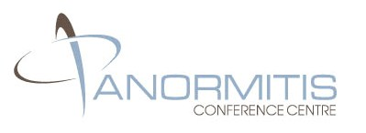 Business meetings & conferences
‘When you need to talk business, be somewhere that inspires conversation!!!’
Let us surpass your expectations during your next meeting, business or social event. The fresh and contemporary meeting rooms of Sensimar Royal Blue Resort & Spa, capable to support every special demand, are located at the main building of the hotel. All conference rooms are ergonomically designed, offer state-of-the-art audiovisual & technical equipment, as well as spreads of tantalizing treats, that add an extra element of prestige to large board meetings and a touch of class to intimate brainstorming sessions. Our dedicated and experienced staff will help you design a well organized and unforgettable event.
Panormitis Conference center features the following meeting & banquet facilities:
- Foyer & Exhibition Space measures 185 square meters
- Fortezza Meeting Room measures 143 square meters for up to 180 persons in theater style with natural light
- Arkadi Meeting Room measures 230 square meters for up to 230 persons in theater style
- 3 Breakout rooms measures ~75 square meters each for up to 85 persons in theater style
- Spacious Outdoor Area with breathtaking views capable to cater up to 450 persons
Audiovisual equipment (upon request)
Audio Systems
- Public address system with lectern and microphones (Lapel, wireless or desk type)
- Hand held Shure HF microphone
- Microphone with lead and stand
- Ceiling-mounted loud-speakers
Visual Aids
- Overhead projector
- Video Camera Recorder (external)
- Fixed and portable screens
- ADSL Videoconferencing (external)
- DVD Player
Business Services
- Secretariat services
- Translation services
- Fax - Photocopy - Laminating Services
- Mobile Telephones / Paging System
- Mail & Courier Services
- Conference name tags
- Internet/e-mail services
- Desktop / portable computer
- Laser colour Printers
- Whiteboards, pin boards, flipcharts
Catering Services
At Sensimar Royal Blue Resort & Spa there is a wide choice of menus, cocktails, buffet menus and coffee breaks, to cover the needs and style of every occasion or event. In case you wish to differentiate your event flavors, our chefs are at your disposal to create a tailor made menu, according to your likes and needs!
Spa Services
Let us pamper you on your wedding day or on your any special day, at the Pure Senses Spa. Choose from a variety of therapies for man, woman and couples and be as radiant and relaxed as you possibly can!

Other Services (upon request)
Leave all details to us, so that you have nothing to worry about and let us help you organize your dream event.
- DJ – Music & Shows arrangements
- Venue and tables decoration
- Photographer/ Video
- Flower service
- Fully air-conditioned rooms
- Independent air cleaning system
- Soundproof movable partitions
- Lighting dimmers
- Direct Telephone lines

Pure Senses Spa

Slip into the “Pure Senses Spa” world. A world that encompasses the best of nature to obtain unique well-being.
Centrally located at the hotel “Royal Blue Resort & Spa”, Pure Senses Spa is a place where you will find the most incredible, unique sensations, where mind, body and spirit converge to feel unforgettable, pleasurable experiences.
The exquisite fragrances throughout the place, let the imagination fly into new cultures and worlds full of exoticism. The combined use of products from different origins such as marine, natural or exotic and the inspiration in various massage techniques that combine tradition and innovation are the basis of “Pure Senses Spa”: a new day of experiencing the most authentic sensations.

The Pure Senses Spa Premises include:
- 700 m2 Fitness Center with Sauna & Hammam
- Indoor Heated Pool with Sea Water
- Complete Massage Treatments menu
- Complete Face Treatments menu
- Private Treatment Rooms for individuals or couples
- Changing Rooms & Private Lockers, separate for men and women
- Relaxation Salon, lounge to distressing rhythms
- Hair & Nail Treatments
- Hairdressers studio

Therapies Categorization
“Pure Senses Spa” bases the classification of its treatments depending on the ingredients used, which constitute the different therapy groups.

Anne Semonin World
- L’ Experience Anne Semonin Facial
- Anne Semonin Eye Brilliance Treatment
- Anne Semonin Serenity Treatment with Hot Stones

Pure Senses Spa Delicatessen
A magnificent world of pleasure for all senses. Incredible treatments which are really enjoyable!
- “Choco Body Sweet Harmony Treatment”
- “Oriental Escape Bath”
- “Red Grapes Bath”

Pure Senses Spa Spice
Cinnamon, Ginger, Saffron, Vanilla…….altogether, are the highlights of an exotic experience which travels you to the distant earths of Far East.
- “Exotic Orient Exfoliation”
- “Mysterious Turkey Massage”
- “Placid Silk Wrap”

Pure Senses Spa Privilege
Ingredients and therapies created to the last detail : from the exquisite textures and sublime fragrances, till the glamorous shiny reflections of gold and pearl.
- “Spa Pearl Luxury Body Therapy”
- “Spa Gold Body Experience”

For the most elegant Spa, the most evocative therapies which lead you to enjoy exquisite experiences!

Facial Treatments
“Pure Senses Spa” has chosen the best products from plants and herbs, sea and nature, to pamper your skin. Enjoy this unique experience!
1.L’ Experience Anne Semonin Facial
This therapy incorporates a client-specific intensive eye and décolleté treatment. Aromatic intensive complexes and serums will boost cellular renewal whilst a firming algae mask will detoxify for absolute skin radiance. This treatment is a complete and effective remedy for removing the stresses of daily life leaving skin firm, smooth and brilliant.

2. Anne Semonin 100% Active Cryotherapie Facial
A contouring and firming facial designed to combat the visible signs of ageing. Excellent for mature, dry and dehydrated skin. Innovative Anne Semonin neurocosmetic ingredients are combined 100% Active Serums and advanced cryo-therapy ice cubes to regain the skin’s natural youthful glow. The result is instantly tightened and firmed skin, a superb brightener for special events and boosting skin vitality.

3. Anne Semonin Deep Marine Purifying Facial
Ideal for combination, oily, congested, problematic skin, this complete deep cleansing purifying treatment combines traditional steam and extraction techniques with rebalancing lymphatic drainage massage. A detoxifying and anti-inflammatory peel off mask and aromatic intensive complexes are used to soothe, calm and rebalance the skin to encourage a visibly clear complexion.

4. Anne Semonin Sun Reflection Facial (after sun)
A gentle therapy to soothe and calm oversensitive, irritated or sun damaged skins prone to redness and irritation. Saturated gauzes combined with soothing aromatic intensive complexes, repair, calm and restore skin equilibrium bringing rapid relief to skin sensitivity. The result skin is left calmed, nourished and comfortable.

5. Anne Semonin Made to Measure Grooming Facial (for men)
Te Phyto – Aromatic Facial is tailored to you. Following a consultation a bespoke facial is created for your skin using our Anne Semonin essential oils, trace elements, serums and botanical oils. Unique to you.

6. Anne Semonin Eye Brilliance Treatment
A detoxifying and radiance boosting treatment for tired eyes, or simply as a regular skin brightener. This enhancing treatment reduces puffiness, minimizes dark shadows and is a welcome treat for those suffering from eye strain, headaches and for contact lens wearers.

7 .Anne Semonin Phyto – Aromatic Facial Collection
These skin enhancing “made to measure facials” ensure effective, visible results. This collection has been designed to be tailor made for your individual skin needs through individually blended plant serums, masks and aromatic intensive complexes.

After an initial consultation, our therapist will assist you in choosing from the following super hydrating therapies:

a. Anne Semonin Extreme Moisture Phyto – Aromatic Facial

b. Anne Semonin Hydra Express Phyto – Aromatic Facial

c. Anne Semonin Soothing Repair Phyto – Aromatic Facial

8. Anne Semonin Serenity Treatment with Hot Stones
A treatment incorporating a full Anne Semonin Phyto – aromatic facial followed by the hot stone massage designed to de–stress both the mind and body. Warmed aromatic oils combined with the therapeutic effects of the stones are used to massage the back, neck and shoulders to restore body balance.

9. Anne Semonin made to measure Grooming Facial

10. “Spa Black Pearl Unique Facial”
It is a sublime and evocative face treatment that looks after the beauty of the skin and allows the skin to enjoy exquisite experiences due to the nutritional properties of the “Black Pearl”.

Body Treatments
Slip into Anne Semonin’s & Germaine De Cappuccini World, using ingredients, coming directly from nature. Exquisite spices, pearl extracts and pure essential oils, all are used to make you feel comfortable and relaxing.

1. Black Sand Body Scrub with Aromatic Body Massage
This ultimate exfoliating experience with Black Sand from Tahiti and aromatic oils actively sweeps away dead surface skin cells, leaving skin wonderfully soft, silky, detoxified and youthfully radiant. This delicate fragrance of exotic verbena promotes a holistic sense of wellbeing and relaxation. Aromatic oils are applied all over the body to deeply nourish, soften and re-mineralize the skin, followed by a revitalizing exfoliation and body wrap. This therapy concludes with a Phyto-Aromatic full body massage, to reawaken your senses.

2. Anne Semonin Express Aromatic Salt Exfoliation
An express aromatic oil and salt scrub the perfect skin preparation, leaving skin deeply nourished, smoothed and hydrated.

3. Anne Semonin Detoxifying Spirulina Wrap
A detoxifying, slimming and energy boosting treatment, this envelopment begins with gentle exfoliation to boost circulation combined with seaweed extracts to harness the powerful cleansing and re-mineralizing benefits of the ocean.

4. Anne Semonin Hydrating Pink Kaolin Clay Body Envelopment
An ultra moisturizing and hydrating body envelopment designed to recondition dry, dehydrated or sun damaged skins. This treatment begins with a full body exfoliation and scalp massage followed by an application of Pink Kaolin clay combined with nutrient rich treatment oils. A perfect full body thirst quencher for tired sensitive skin.

5. Anne Semonin Anti – Cellulite Therapy
A specialized treatment designed to stimulate the body’s system and target areas of fluid retention, cellulite and uneven skin tone. Using massage and lymphatic drainage techniques the legs and feet are massaged to restore circulation and a firming and detoxifying mask is applied to relieve blockages and tone the skin. A course of tretments is recommended.

6. “Exotic Orient Exfoliation”
An exfoliation based on an incredible blend of the finest and most expensive spices in the world, together with oriental resins and woods, bamboo particles, poppy seeds and nutmeg. It provides hydrating, nourishing properties.

7. “Placid Silk Wrap”
Body wrap based on “silk extract”. Its smooth texture works like a second skin and allows massage with the Obsidian massage stones. The skin is left smooth and deeply hydrated for a long time.

8. “Choco Body Sweet Harmony Body Treatment”
It is a soft, warm and enjoyable treatment based in cocoa’s pure extract. It has a triple – action effect: hydration, anti – oxidizing and anti – cellulite. The mild cocoa butter nourishes and smoothes the skin and leaves a sensation incredibly “sweet”.

9. “Spa Pearl Luxury Body Therapy”
The magic of the moon and the beneficial properties of pearls create a luxurious, sophisticated treatment that hydrates, softens, firms and covers the skin with a beautiful, shiny reflection.

10. “Spa Gold Body Experience”
The power of the sun and “golden algae” are resulting in a glamorous and revitalizing therapy that protects, stimulates and enriches the skin, preventing skin ageing while at the same time is covering the skin with a gold veil.

11. “Cleopatra Body Sensation”
A therapy with deep moisturizing effects. The combination of rich cream, almond oil and pure essential oils, gives skin the ultimate hydration and nutrition, especially for the hot summer days.

12. “Rasul Experience”
The ultimate therapy for two. The ingredients of the earth are binding together to offer the perfect treatment and hydration for the body in a relaxing and sensual ambient.

Massages
Special Massages
Combining innovation and tradition, ingredients like exotic spices, shells, stones, etc, we try to travel you to mysterious worlds of pure relaxation.
- “Mysterious Turkey Massage”
It is carried out with Saffron Delight, an exclusive delight based on saffron that is massaged in an exceptional way. It provides anti – oxidizing properties. The protocol is carried out with a silky foulard and with the exclusive stick.
- “Exotic Ceylon Massage”
It is carried out with Cinnamon Delight that allows a pleasurable massage combining shells.
3. “The Obsidian Holistic Massage”
This treatment is inspired from the ancient philosophy and is combining Obsidian and Onyx stones from the volcanic lands of Mexico. The result is a complete state of relaxation that leads to the ultimate harmony between body, mind and soul.
- Traditional Thai Massage
- "Pure Senses Spa" Aromatherapy Full Body Massage
- "Ayurveda" Special Body Massage
- "4 Hands" Massage

Simple Massages
Even the most simple massage is the best way to start your journey to pleasure and relaxation…..
- Relaxing Body Massage
- Anti - stress Back Massage
- Reflexology
- Head - Face Massage

Hydrotherapies
Aromas, spices, fruits, all coming from the Far East, combining with the unique experience of hydro massage, give you indulgence and well-being.
- "Oriental Escape" bath
- "Cleopatra's" Cream bath
- "Red Grapes" bath
- Thalassotherapy

Feet & Hands Treatments
1. Anne Semonin Perfect Hands Treatment
A softening arm, hand and nails treatment includes gentle exfoliation and a luxurious southern sea ocean hand bath. Cuticles and nails are nourished with warmed aromatic oils massage and rich, creamy Kaolin mask used to refine, nourish and protect the skin. Combined with a complete manicure the result is perfectly groomed hands and nails.

2. Anne Semonin Soul Foot Therapy
This nourishing and conditioning foot and nail treatment begins with a mineral enriched footbath and exfoliation ideal for softening the skin. Warmed aromatic oils and active serums are then applied and the feet are enveloped with a Pink Kaolin mask and a rich cream massage relieves tension, nourishes and repairs the skin. The feet are left groomed and revitalized.

Hairdressers Studio
Some services are classical. We are here to ensure you, that even these treatments will lead you to the best ever experience.

Hairdressers
- Haircut
- Hair Styling
- Hair Reforming
- Coiffure for ‘Bride to Be’
- Hair Cleaning
- Hair Colouring
- Reflet
- Streaks
- Straightening
- Hair Therapies
- Hair Masks
Waxing
- Full Leg
- Half Leg
- Full Arm
- Half Arm
- Under Arm
- Bikini
- Brazilian Bikini
- Upper Chin & Lip
- ‘Pure Senses Package’ (full leg & bikini)
Pedicure – Manicure
- Manicure
- Pedicure
- French Manicure
- French Pedicure
- Pure Senses Spa Manicure
- Pure Senses Spa Pedicure
- Nail Art – Strass (per piece)
- Nail Shape & Varnish (hands)
- Nail Shape & Varnish (feet)
- Anne Semonin Perfect Hands Treatment
- Anne Semonin Sole Foot Therapy
- Citrus Spa Refresh Treatment
Maquillage
- Day Time make-up
- Evening Make up
- Bridal Make up

Day Packages
Chill out and relax. This spa is designed for you to experience blissful relaxation, grooming and rejuvenation! Visit the Pure Senses Spa and choose among the following day packages!
- Ultimate Spa Journey of Anne Semonin
  - Aromatic self exfoliation, aromatherapy full body massage, (Spa Lunch), Hands Treatment, Foot therapy, moisture phyto aromatic Facial
- Time Together (treatment for two)
  - Rasul Experience, moisture phyto aromatic Facial, Thalassotherapy, (Spa lunch for 2), aromatherapy full body massage, foot therapy
- Anne Semonin Mother to be treatment
  - A relaxing, unwinding therapy for expectant mothers, targeting areas of aches and pains and rejuvenating the face and body to give ultimate radiance back to the skin. This nurturing therapy will help treat muscular aches, fluid retention, stress and fatigue.
- Amimoni - Salt exfoliation, clay body envelopment, reflexology
- Ariti - Exotic orient exfoliation, oriental escape bath- relaxing body massage
- Artemis - thalassotherapy, Rasul experience, aromatotherapy full body massage
- Charis - thalassotherapy, exotic ceylon body massage, sole foot therapy
- Lefkothea - thalassotherapy, Rasul experience, antistress back massage, Cleopatra body sensation
- Danai - Cleopatra cream bath, Choco body sweet harmony, soothing remedy facial, eye brilliance treatment
- Royal Iris - thalassotherapy, Spa Gold Body Experience, Obsidian Holistic Massage, Spa Black Pearl Unique Facial, Spa Citrus Refresh Hands Treatment

Guest Services & Facilities
At Sensimar Royal Blue Resort & Spa there is a wide array of services and facilities for all our discerning guests, so that the utmost pleasure and satisfaction is achieved. Our staff, highly committed to excellence, is at your disposal to make your stay an unforgettable experience!

- Private Beach
- 2 Tennis Courts
- 1 Mini Golf Court
- Multilingual staff
- 24hrs Room Service
- Guest Relations
- Doctor on call
- Baby sitting on call
- Private Dining options
- Destination Assistance
- Special Meals upon request
- Dry / Laundry cleaning service
- Luxury transport upon request
- In House Villa Treatments upon request
- FunLand Kid’s Club
- Wi-Fi Internet Connection
- Internet Corner
- Postal Services
- Parking
- Transfer from/to the airport upon request
- Express Check In – Check out
- Car Rental services
- Private Chef Services upon request
- Private Dining in Room upon request
- Business center & secretariat services upon request
- Beach services
- Security services
- Tennis lessons upon request
- ‘Gems and more’ Jewelry Shop
- Mini Market & Holiday Boutique

Contact Information

To make reservations, arrange your event or learn more information about Sensimar Royal Blue Resort & Spa, please use the information below to get in contact with our experienced staff.

Sensimar Royal Blue Resort & Spa

Virginia Fthenou Trouli
PR & Marketing Manager
Panormo Geropotamou
74057 Rethymnon, Crete
T. + 30 28340 55000, F. +30 28340 55055
E. info@royalblueresort.com
W. www.royalblueresort.com

