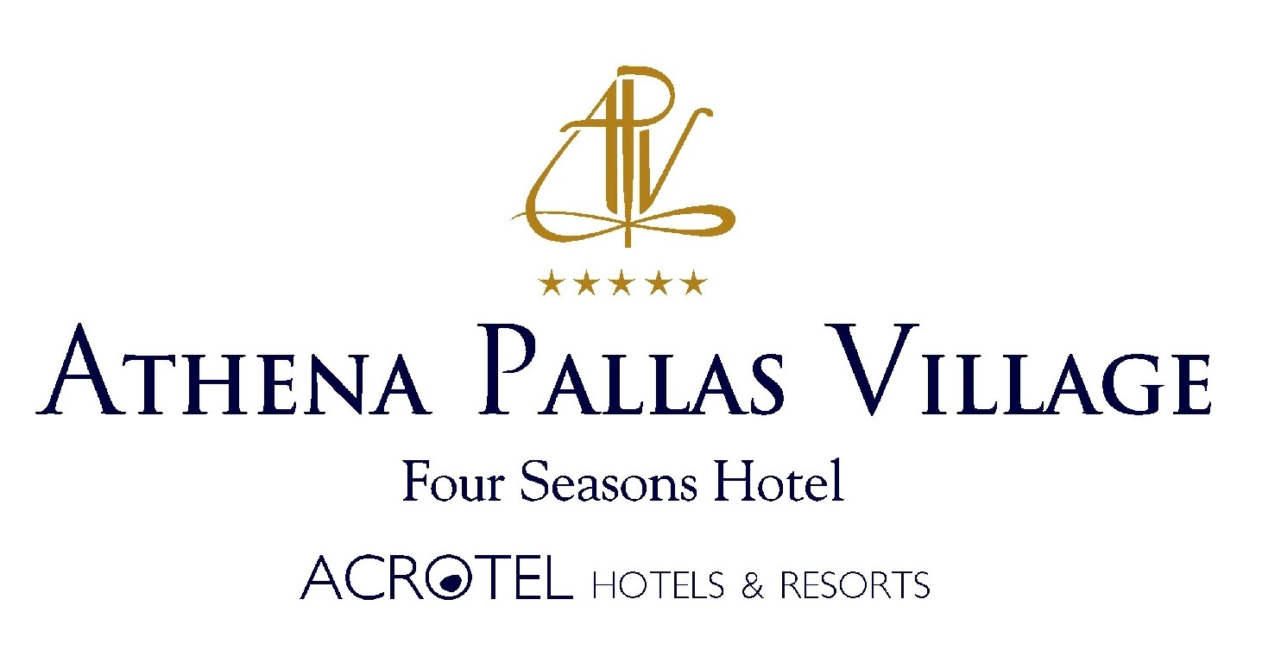
LOCATION
The hotel Athena Pallas Village is located at Elia Beach, in Sithonia, Province of Halkidiki.in a calm and beautiful environment and it looks like a small traditional village. In the whole peninsula of Sithonia you will find beautiful beaches with clearly blue water. The resort give you a lot of possibilities to rest and to enjoy the wonderful nature. The small distance from the hotel to Nikiti (9 km) and Neos Marmaras (11 km) offers every guest many choices for recreation; you can arrive easily with the hotel’s bus.

FACILITIES - INFRASTRUCTURE
The hotel unit extends harmoniously over 30,000 square meters with six categories of buildings and one central building with unique architecture. The Athena Pallas Hotel possesses all the necessary elements and infrastructure to provide a high level of services that can cover the desires and the expectations of every visitor for a comfortable and unique stay. In this authentic village, the visitor may taste traditional Greek recipes, as well as brushstrokes of Mediterranean cuisine at the main restaurant, ‘Doxato’, but also at the traditional Greek taverna, ‘Aigaion Gefsis’ (Aegean Flavor).

At the Athena Pallas Village Hotel there are 6 different bars:
- The “Athena” Lobby Bar
- The “Armonia” Pool Bar
- The “Pyrgos” Pool Bar
- The “Petrino” Pool Bar
- The Roof Garden Bar with a view of the sea of the Toroneos Gulf
- The Beach Bar
The 6 bars stand out for the quality of their products, their services, and the immediate response to guests. At each one of them, the client may taste the Special Cocktails, Snacks, and various meals.

63088 Nikiti / Halkidiki / Greece
Tel: +30 23750 23000 / Fax: +30 23750 23001
www.athena-pallas.gr / sales@athena-pallas.gr

SPA
In the year 2007 was created for our guests a new super-modern 1200 square meter Spa center with a covered, heated pool, a state of the art gym (free of charge), as well as a sauna, a Turkish bath, a Jacuzzi, and massage services (with charge). Beyond. can always our tennis courts and mini golf course keep every visitor in shape (with charge).

The traditional Greek Athena Pallas village also possesses 3 fresh water swimming pools with separate children’s pools. The souvenir shop and mini market, the jewelry store, as well as the boutique of silks from Soufli are available to the visitor who wants to buy a souvenir.

. HOLIDAYS FOR THE ENTIRE FAMILY
The playground and the children’s club offer programs for keeping young guests creatively occupied, with the presence of specialized personnel. In addition, the game room, with two bowling lanes, table soccer, a billiards table, the Internet room, and the movie theater (Cinepolis) will provide children and adults with the spark for enjoyment and pleasure.

ACCOMMODATIONS
The hotel facility possesses 66 standard rooms with two beds, 14 family rooms / suites, 40 Superior rooms, 30 suites, 3 Executive Suites, 2 Grand Suites, and 20 comfortable stone houses.
All the standard double rooms are with an area of 22 square meters, furnished with taste. They contain a double bed and a telephone with an outside line, satellite television, pay TV, individually adjustable air conditioning, room service, wake-up call service, a Mini bar, a bathroom with a shower, a hair dryer, and a balcony.

The family rooms or suites consist of two areas with 51 square meters in total (with a connecting door). Besides the facilities of the standard rooms, they offer a bedroom and a living room with a couch that can be converted to a double bed, as well as two bathrooms.
63088 Nikiti / Halkidiki / Greece
Tel: +30 23750 23000 / Fax: +30 23750 23001
www.athena-pallas.gr / sales@athena-pallas.gr

The Superior rooms are rooms with an area of 28 square meters and are furnished in new classic style. Besides the double bed, they contain a small living room with a sofa bed (for two children), individually adjustable air conditioning, satellite television, pay TV, a Mini bar, room service, wake-up call service, a safe, and a spacious bathroom with a corner bathtub, a hair dryer, bathrobes, and slippers.\

The modern furnished “Armonia” Suites: their size is 35 square meters, they are all located around the new swimming pool, and they contain a double bed and a separate living room with a sofa bed, a large balcony with a table and film director’s chairs in front of a beautiful pool in a ravine with green plane trees and a bar to serve our clients. They also possess a Mini bar, a safe, 2 satellite televisions, pay TV, room service, wake-up call service, individually adjustable air conditioning, and a bathroom with a multi-function shower (Jacuzzi showerhead), bathrobes, and slippers.

The “Wood & Stone Houses” are 75 square meter buildings that were just built in the summer of 2007 on a green lawn, around a beautiful 600 square meter swimming pool with waterfalls, small islands, gushing water, a Jacuzzi, and a children’s pool. They are furnished with taste and contain a bedroom, a living room with a fireplace, and a second room with a wooden internal staircase. They contain 2 plasma satellite televisions, pay TV, room service, a Mini bar, wake-up call service, a safe, and individually adjustable air conditioning. All the houses include a stone balcony, a covered veranda with a sitting room, a small garden and a magnificent location 6 meters of distance from the newly designed swimming pool.

The Executive Suites: their size is 52 square meters. They are furnished with taste and traditional furniture in the Macedonian style. They contain a bedroom, a living room with a fireplace, and a bathroom with a bathtub (a Jacuzzi). On the inside, the rooms are made of stone and wood. These rooms offer a plasma satellite television, pay TV, room service, a Mini bar, individually adjustable air conditioning, wake-up call service, a safe, a sauna, and a wonderful view!!!
The “Patriko” (Ancestral Home) Suite takes you to other eras, with the uniquely traditional aesthetics of its old wooden beams, which will charm even the most demanding. Among other tings, it also contains a small children’s room with an internal wooden staircase!!!

63088 Nikiti / Halkidiki / Greece
Tel: +30 23750 23000 / Fax: +30 23750 23001
www.athena-pallas.gr / sales@athena-pallas.gr

ATHENA PALLAS VILLAGE OFFERS HIGH-LEVEL SERVICES
• 66 double rooms with an 8 square meter balcony
• 14 family rooms and family suites
• 40 superior rooms
• 30 suites
• 20 wood & stone houses
• 3 executive suites

• Medical assistance in case of emergency
• Mini market and gift shop
• Organized recreation program for our young friends
• Restaurants
• Outdoor a la carte restaurant next to the swimming pool
• Children’s mini club / child minding
•Activities room with two bowling lanes, billiards, and the movie theater (Cinepolis)
• Internet Access
• Conference rooms for up to 500 people
• Folklore Museum
• Distance from the beach: 10 meters

Additional benefits:
• Free baby cribs
• Children’s chairs
• Safe
• Free sun beds and umbrellas at the pool.
• Private hotel bus (with a charge) to Neos Marmaras and Nikiti
• Car rental office
Sports & Wellness:
With a charge
• Tennis court with lights
• Mini golf course
• New state of the art Spa Health Center with a sauna, Jacuzzi, Turkish bath, solarium, and massage services
• Shuttle Bus Service for clients
Internet corner

Free of charge
• Table tennis
• New gym
• Indoor heated swimming pool
The Hotel Athena Pallas Village is open all year round.

We suggest you to visit some sights in the area of Chalkidiki as below:

- mini cruise with the pirate ship to Mount Athos
- stalactite cave Petralona
- antique Olynthos
- Aristoteles-park in Stageira
- traditional museum in Nea Moudania
- the traditional architecturally town Arnaia
- traditional museum in Ierissos
- farm with the possibility for horse riding in Platamona

We enriched the variety of our benefits and services, in order for them to correspond to your expectations of a stay in an international five-star hotel, while simultaneously maintaining the distinct character and the warm atmosphere that the clients of the ATHENA PALLAS VILLAGE have been able to enjoy for years now.
We invite you all to visit our hotel and enjoy your stay.. Our staff, which is always willing to serve you and to make your stay here comfortable., Enjoy also the outstanding flavours of our unique cuisine.
For more information and questions, please send us an e-mail to the following address: sales@athena-pallas.gr

63088 Nikiti / Halkidiki / Greece
Tel: +30 23750 23000 / Fax: +30 23750 23001
www.athena-pallas.gr / sales@athena-pallas.gr

