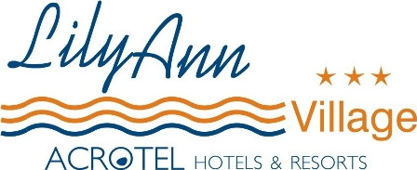

LOCATION

The hotel Lily Ann Village 3* is located in the village of Nikiti and is just 400 m
away from the excellent sandy beach.
You will find the hotel very easy either you travel with the car (100 m from the main road) or with the bus (800 m from the bus station).
Close to the hotel you will find locations for entertainment like bars, restaurants and a lot of different shops.

Nikiti, which is very famous for the production of honey, offers especially for the summertime some cultural events, like the international swimming competition “Diaplous”, and more athletic competitions.

Infrastructure

The hotel consists of 4 buildings surrounded by beautiful gardens and in the middle there is a sweet water pool with Pool/Snack bar and around of the pool you can use the sun beds and umbrellas for free.
Also it has a nice lobby/reception with a TV corner and air-conditioned restaurant.

Accommodation

Lily Ann village has 20 double rooms and 20 family studios.

All the room combines the friendly area with the comfort. They possess telephone, air condition, fridge, SAT-TV, bathroom with shower and balcony.

The family studios offer accommodation for max. 4 person. They are 2 room apartments and possess one double bed and a sofa bed or 2 single beds.

We are pleased to welcome you !

63088 Nikiti Halkidiki, Greece
Tel.: 23750 23000 Fax: 23750 23001 www.acrotel.gr

